**A COMPREHENSIVE ANALYSIS OF FINANCIAL PERFORMANCE: INSIGHTS FROM A LEADING BANKS**

**1 .INTRODUCTION:**

**1.1 Overview:**

The banking field has been transformed in the recend years . In order to know the growth of Banks we have developed this project by analysing the growth of various banks. We can analyse the growth of banks by comparing with the previous years performance.

Financial performance analysis include and interpretation of financial statements in such a way that it undertakes a full diagnosis of the profitability and financial soundness of the business. The financial analyst program provides vital methodologies of financial analysis.

**1.2 Purpose:**

This project can be used to analyse the bank related data and extract some insights from the data of Banks for taking actions for the improvement of their performance.

Its purpose is to convey an understanding of some financial aspects of a business firm. It may show a position of a period of time as in the case of a Balance Sheet, or may reveal a series of activities over a given period of time, as in the case of an Income Statement.

**2. PROBLEM DEFINITION & DESIGN THINKING:**

**2.1 Empathy Map:**

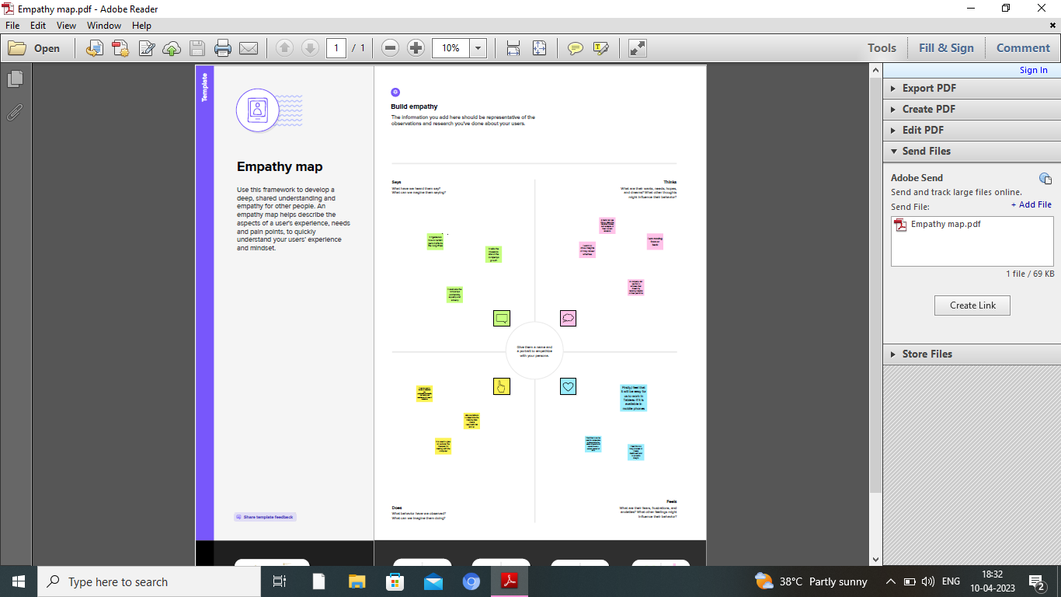

**2.2 Ideation & Brainstorming Map:**

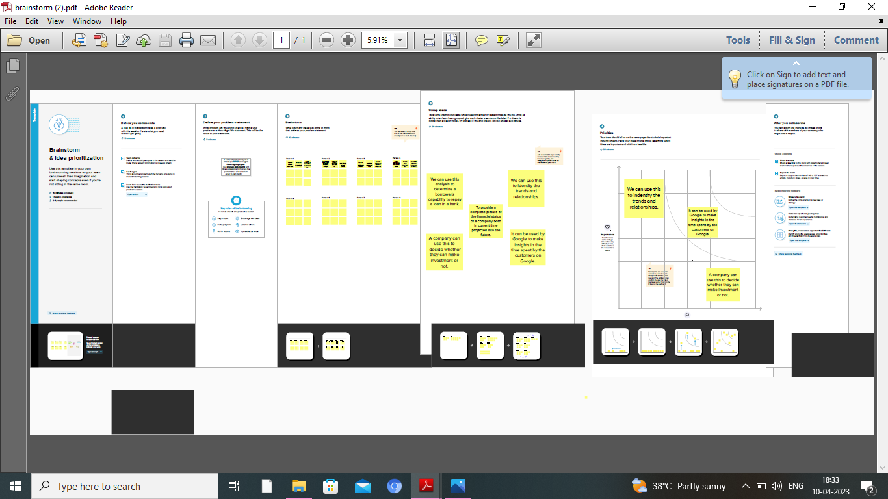

**3. RESULT:**

**Dashboard: 1**

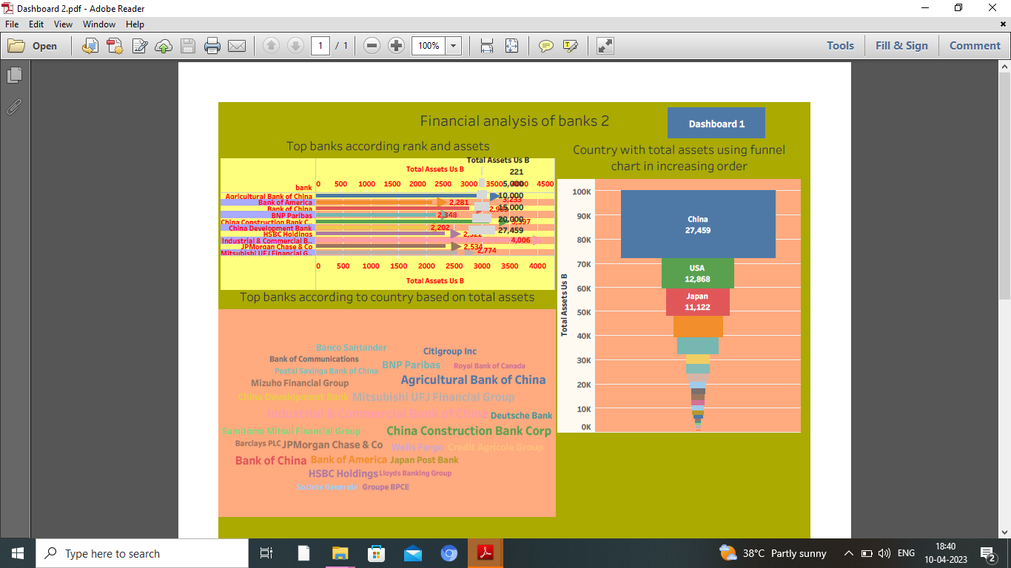

**Dashboard:2**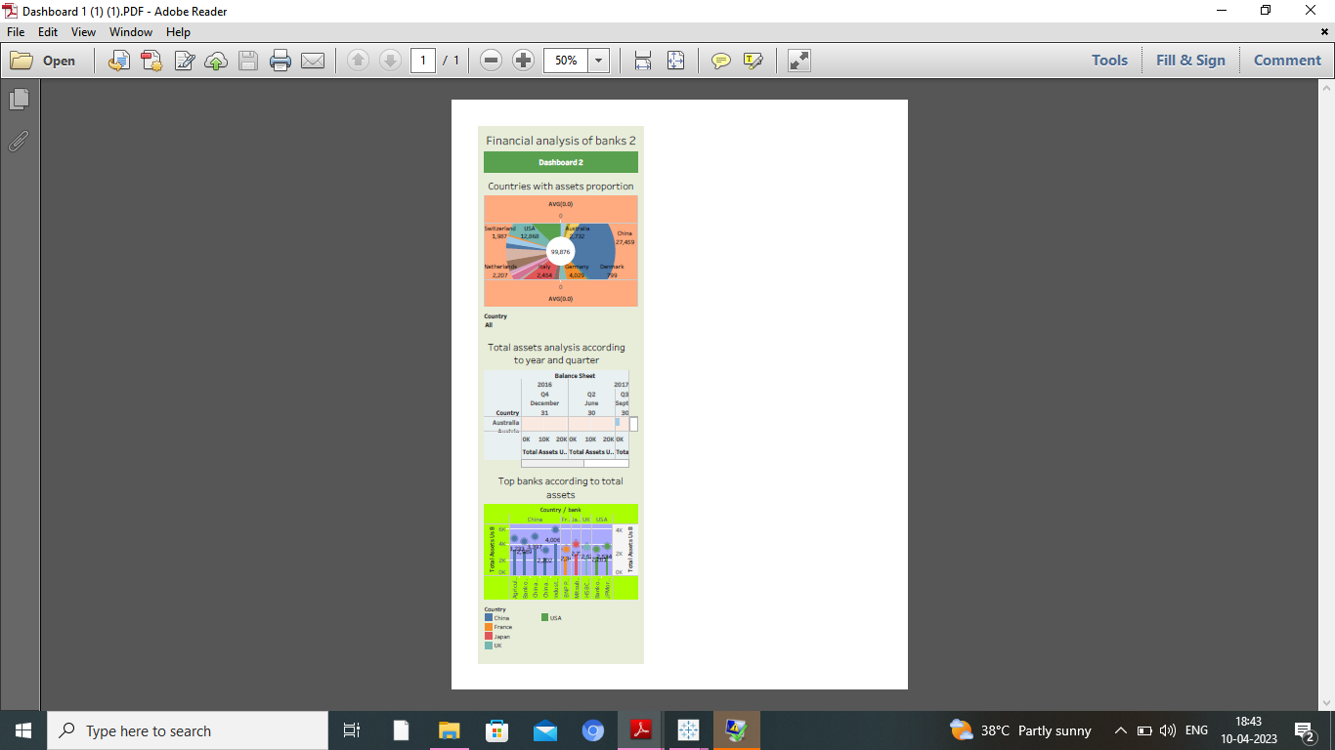

FINAL DASHBOARD OUTPUT IN TABLEAU PUBLIC:

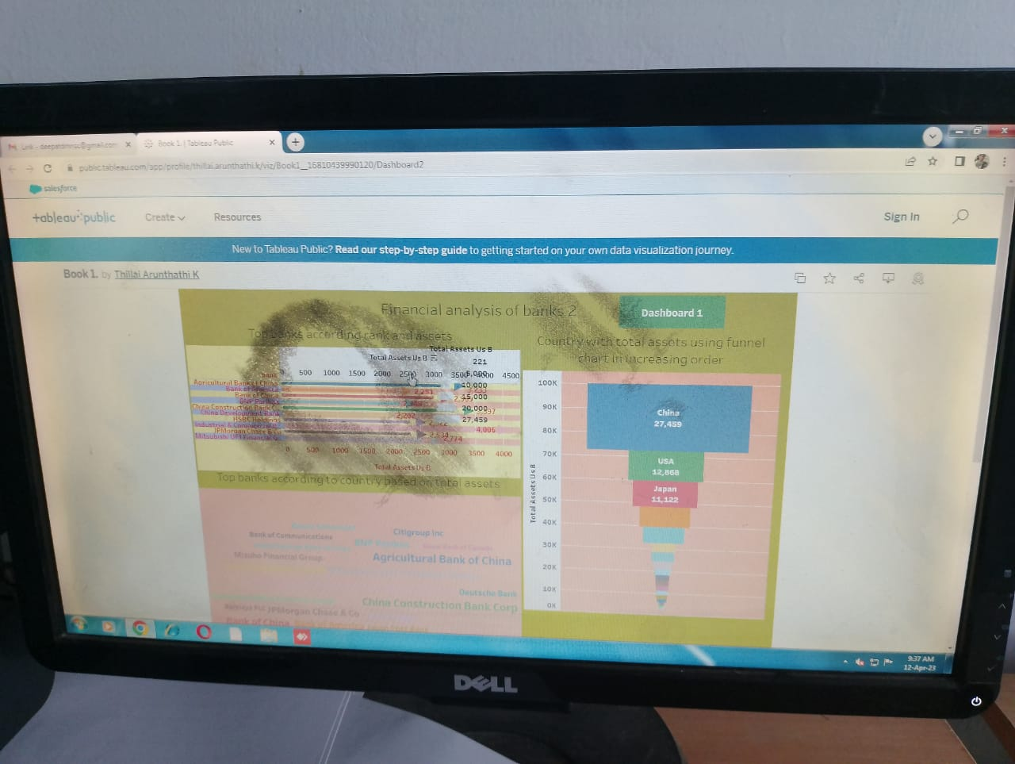

**Story:** 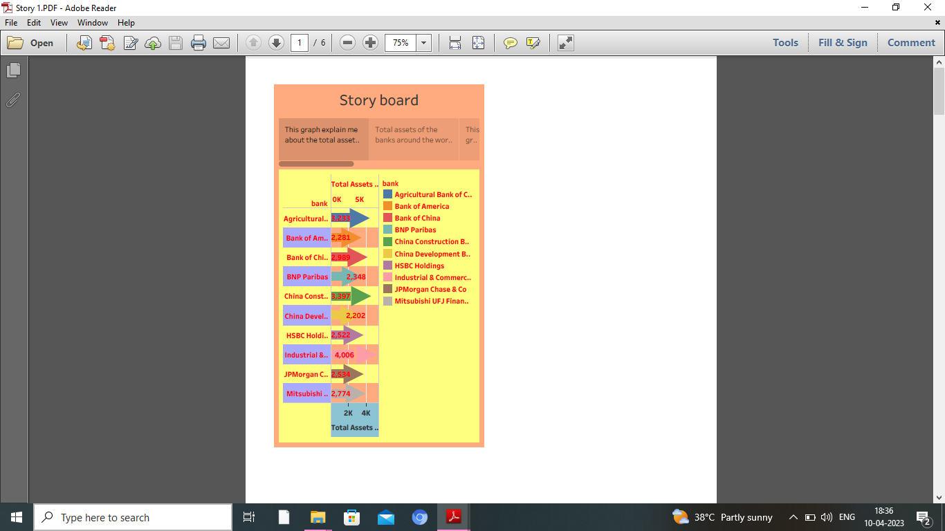

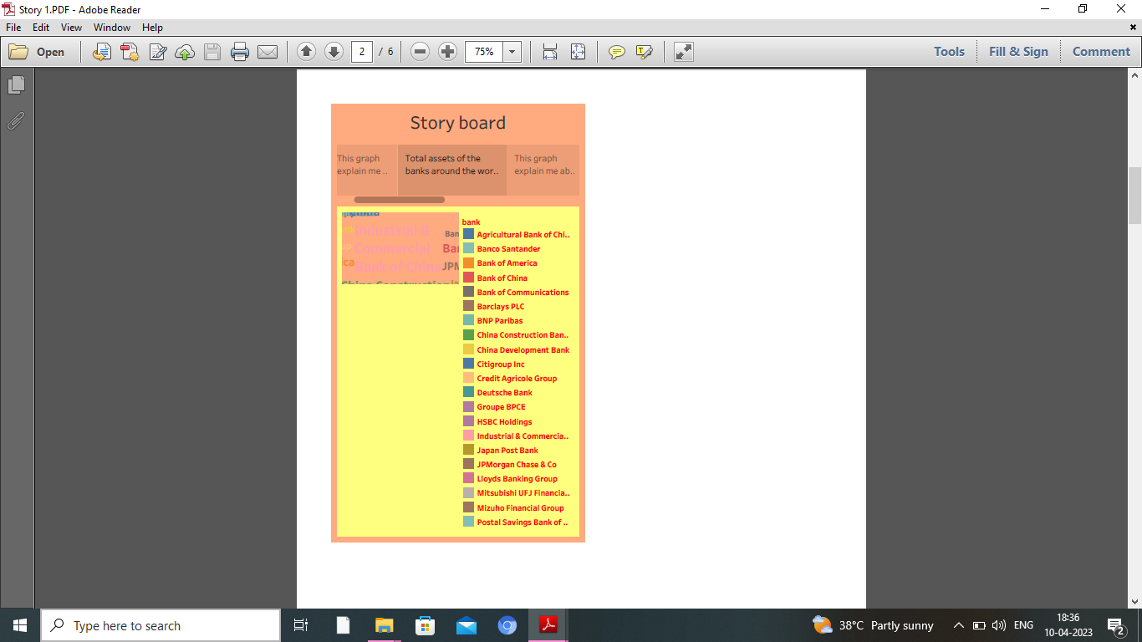

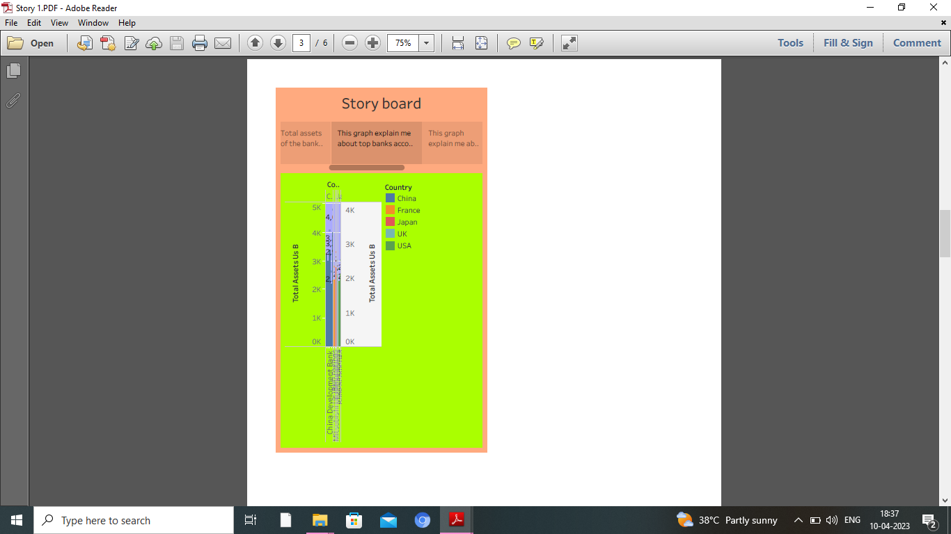

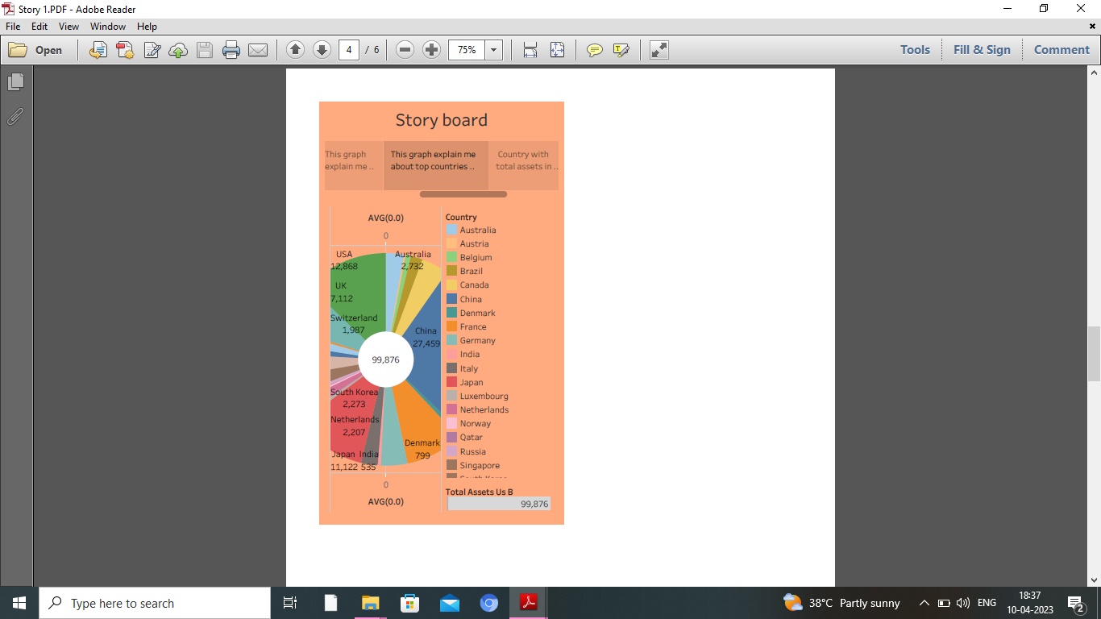

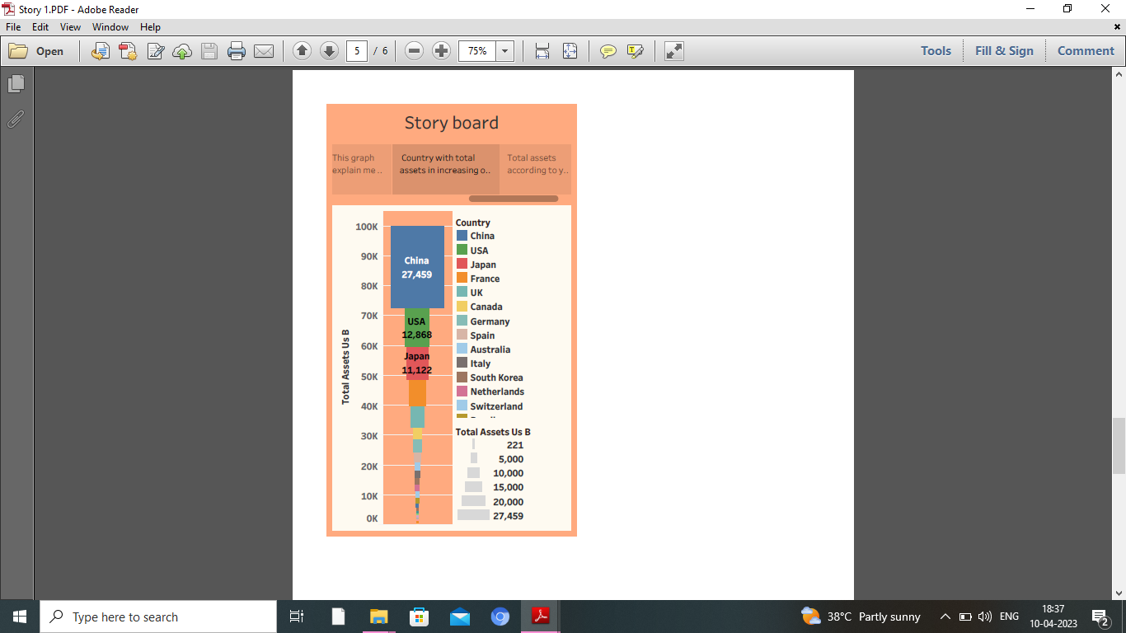

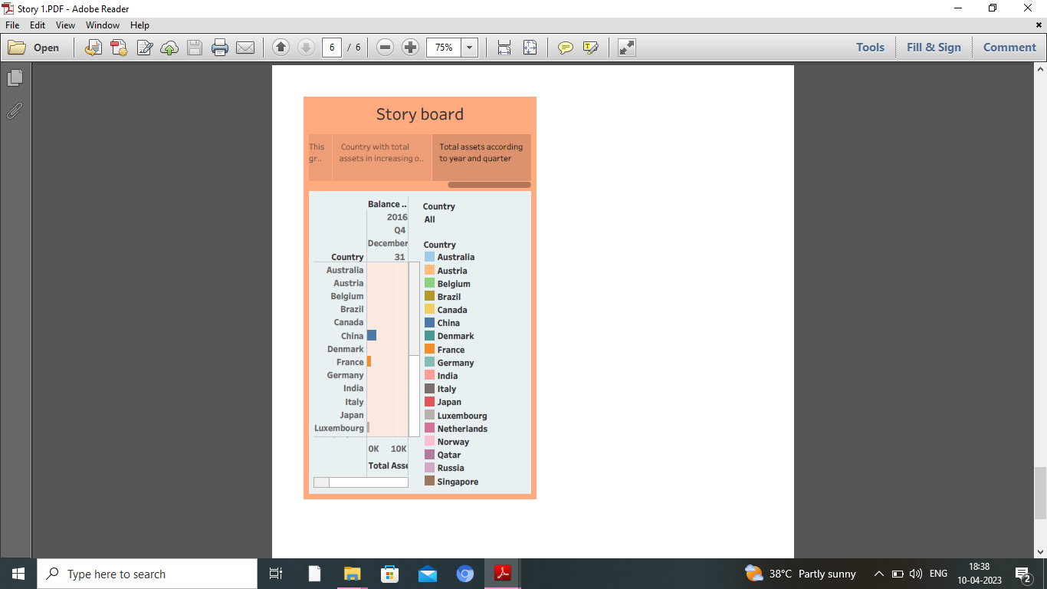

**FINAL STORYBOARD OUTPUT IN TABLEAU PUBLIC:**

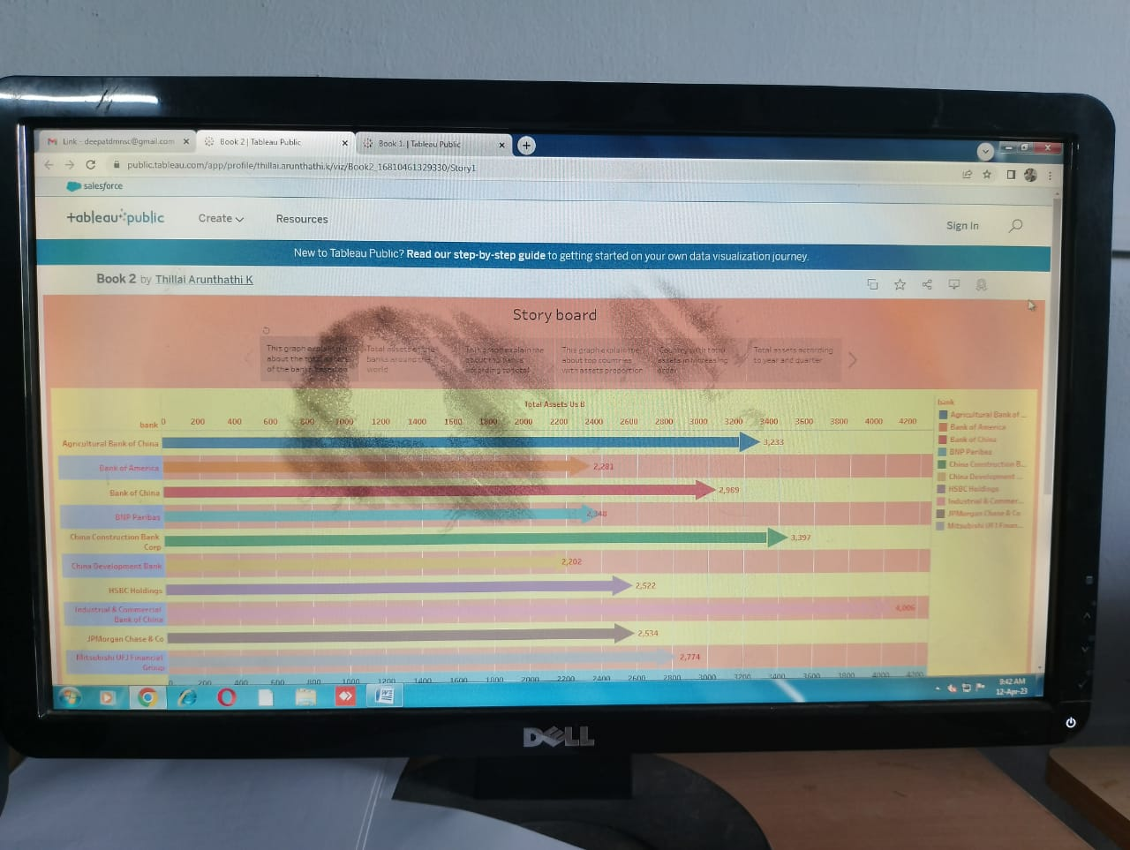

**4. ADVANTAGES & DISADVANTAGES:**

**Advantages :**

It can be used to derive insights which is very easy for us to know the level of growth in each area.

A company’s financial performance about its general well-being. It’s a snapshot of its economic health and the job its management is doing – providing insight into the future: whether its operations and profits are on track to grow and the outlook for its stock.

**Disadvantages :**

The only disadvantage what we feel is it is a long way process in finding insights and collecting data.

Some other limitations of financial analysis are mentioned below:

The financial analysis does not contemplate cost price level changes. The financial analysis might be ambiguous without the prior knowledge of the changes in accounting procedure followed by an enterprise.

5. APPLICATIONS

It can be used in Banking sectors. Also, it can be used in Hotels and Super markets to know their growth and compare it with other industries.

**6. CONCLUSION**

It is a process of comparing a company’s performance with other ones . It can also be used to know where the company has made high investment and also to know the loss in which sector.

**7. FUTURE SCOPE**

It has a great scope in the upcoming years inorder to know the growth and loss in each sector of the company

Since the world is growing electronically, it will definitely grow in the future.

**8. APPENDIX:**

**A. Source Code :** Nil